EXPRIMENT 1

Aim
To perform vector and matrix operations using NumPy, calculate cosine similarity between customers, implement a dense layer using \(y=Wx+b\), and visualize customer–book recommendation scores using Matplotlib.

Algorithm

Task 1: Build Customer–Genre and Genre–Book Matrices
Algorithm:
- Start the program.
- Import the NumPy library.
- Create a customer–genre matrix C containing the ratings of 6 customers across 5 genres.
- Define the five genres as Fiction, Romance, Mystery, Science, and Technology.
- Create a genre–book matrix B containing the weights of 4 books across the 5 genres.
- Use np.array() to store both matrices as NumPy arrays.
- Display the customer–genre matrix and genre–book matrix.
- Verify that the dimensions are \(6\times5\) and \(5\times4\), respectively.
- Stop.

Task 2: Perform Mathematical Operations
Algorithm:
Start the program.
Import the NumPy library and initialize the customer–genre matrix C and genre–book matrix B.
Calculate the dot product:
- Select the rating vectors of Customer 1 and Customer 2.
- Multiply their corresponding elements.
- Add the products to obtain the dot product.
Perform matrix multiplication:
- Multiply C by B using the @ operator.
- Store the resulting customer–book recommendation score matrix in S.
Calculate the transpose:
- Apply the transpose operation C.T.
- Display the matrix with rows and columns interchanged.
Check the matrix inverse:
- Calculate the Gram matrix using G = C.T @ C.
- Check whether the Gram matrix has full rank.
- If it has full rank, calculate its inverse using np.linalg.inv(G).
- Otherwise, display a message stating that the ordinary inverse does not exist.
Perform element-wise addition:
- Add 1 to every element of C.
- Display the resulting matrix.
Perform element-wise multiplication:
- Multiply C by itself element by element.
- Display the resulting matrix.
- Display all calculated results.
Stop.

Task 3: Calculate Cosine Similarity Between Customers
Algorithm:
- Start the program.
- Import NumPy and initialize the customer–genre matrix C.
- Calculate the Euclidean norm of each customer's rating vector using np.linalg.norm(C, axis=1).
- Calculate the dot products between all pairs of customers using C @ C.T.
- Calculate the product of the norms of every customer pair using np.outer().
- Divide each dot product by the corresponding product of norms to obtain the cosine similarity matrix.
- Display the cosine similarity matrix.
- Exclude the diagonal values because each customer's similarity with themselves is 1.
- Consider only the upper triangular part of the matrix to avoid duplicate customer pairs.
- Identify the maximum similarity value using np.argmax().
- Determine the corresponding customer indices using np.unravel_index().
- Display the two most similar customers and their cosine similarity value.
- Stop.

Task 4: Implement a Dense Layer Using \(y=Wx+b\)
Algorithm:
- Start the program.
- Import NumPy and initialize the customer–genre matrix C and genre–book matrix B.
- Select the first row of C as the input vector x, representing Customer 1's ratings.
- Transpose the genre–book matrix using W = B.T to obtain the weight matrix of size \(4\times5\).
- Initialize the bias vector b with four values, one for each book.
- Multiply the weight matrix W by the input vector x using Wx = W @ x.
- Add the bias vector to the multiplication result using y = Wx + b.
- Display the input vector, weight matrix, bias vector, intermediate result Wx, and final output y.
- Identify the book with the highest output score.
- Stop.

Task 5: Visualize the Recommendation Score Matrix as a Heatmap
Algorithm:
- Start the program.
- Import NumPy and Matplotlib.
- Initialize the customer–genre matrix C and genre–book matrix B.
- Calculate the recommendation score matrix using S = C @ B.
- Create a figure using plt.figure().
- Display the score matrix as a heatmap using plt.imshow(S, cmap="YlGnBu").
- Add a color bar to indicate the relationship between colours and recommendation scores.
- Label the horizontal axis with Book A, Book B, Book C, and Book D.
- Label the vertical axis with Customer 1 through Customer 6.
- Display the numerical score inside each heatmap cell using plt.text().
- Add the title and axis labels.
- Adjust the layout using plt.tight_layout().
- Display the heatmap using plt.show().
- Stop.
Code
import numpy as np
import matplotlib.pyplot as plt
np.set_printoptions(precision=2, suppress=True)
# Task 1: Build the matrices
# Customer-Genre Matrix (6 x 5)
# Genres: Fiction, Romance, Mystery, Science, Technology
C = np.array([
[5, 4, 1, 0, 2],
[4, 5, 1, 0, 2],
[1, 0, 5, 4, 3],
[0, 1, 4, 5, 3],
[3, 2, 2, 1, 5],
[2, 3, 1, 2, 4]
], dtype=float)

# Genre-Book Matrix (5 x 4)
# Books: A, B, C, D
B = np.array([
[0.9, 0.1, 0.2, 0.3],
[0.8, 0.2, 0.1, 0.4],
[0.1, 0.9, 0.3, 0.2],
[0.2, 0.8, 0.4, 0.1],
[0.3, 0.2, 0.9, 0.8]
], dtype=float)
print("TASK 1: MATRICES")
print("Customer-Genre Matrix (6x5):\n", C)
print("\nGenre-Book Matrix (5x4):\n", B)
# Task 2: Mathematical operations
# Dot product
print("\nTASK 2: MATHEMATICAL OPERATIONS")
print("Dot product of Customer 1 and Customer 2:")
print(np.dot(C[0], C[1]))
# Matrix multiplication: Customer-Book scores
S = C @ B
print("\nMatrix Product / Score Matrix (6x4):\n", S)
# Transpose
print("\nTranspose of Customer-Genre Matrix (5x6):\n", C.T)
# Inverse: rectangular matrices have no ordinary inverse.
# Check inverse of the square Gram matrix C.T @ C.
G = C.T @ C
print("\nGram Matrix (5x5):\n", G)
if np.linalg.matrix_rank(G) == G.shape[0]:
print("\nInverse of Gram Matrix:\n", np.linalg.inv(G))
else:
print("\nGram matrix is singular; ordinary inverse does not exist.")
# Element-wise operations
print("\nElement-wise Addition (C + 1):\n", C + 1)
print("\nElement-wise Multiplication (C * C):\n", C * C)
# Task 3: Cosine similarity between customers
norms = np.linalg.norm(C, axis=1)
similarity = (C @ C.T) / np.outer(norms, norms)
print("\nTASK 3: COSINE SIMILARITY MATRIX:\n", similarity)
# Find the most similar pair without comparing a customer to itself
upper = np.triu(similarity, k=1)
i, j = np.unravel_index(np.argmax(upper), upper.shape)
print(f"Most similar customers: Customer {i+1} and Customer {j+1}")
print(f"Cosine similarity: {similarity[i, j]:.4f}")
# Task 4: Dense layer y = Wx + b for Customer 1
x = C[0] # Customer 1 ratings
W = B.T # Weight matrix (4 x 5)
bias = np.array([0.5, 0.5, 0.5, 0.5])
Wx = W @ x
y = Wx + bias
print("\nTASK 4: DENSE LAYER")
print("Input x:", x)
print("Weight matrix W:\n", W)
print("Bias b:", bias)
print("Wx before bias:", Wx)
print("Final output y = Wx + b:", y)
# Task 5: Heatmap of recommendation scores
plt.figure(figsize=(8, 5))
plt.imshow(S, cmap="YlGnBu", aspect="auto")
plt.colorbar(label="Recommendation Score")
plt.xticks(range(4), ["Book A", "Book B", "Book C", "Book D"])
plt.yticks(range(6), [
"Customer 1", "Customer 2", "Customer 3",
"Customer 4", "Customer 5", "Customer 6"
])
for row in range(S.shape[0]):
for col in range(S.shape[1]):
plt.text(
col, row, f"{S[row, col]:.1f}",
ha="center", va="center", color="black"
)
plt.title("Customer-Book Recommendation Score Heatmap")
plt.xlabel("Books")
plt.ylabel("Customers")
plt.tight_layout()
plt.show()
Output\
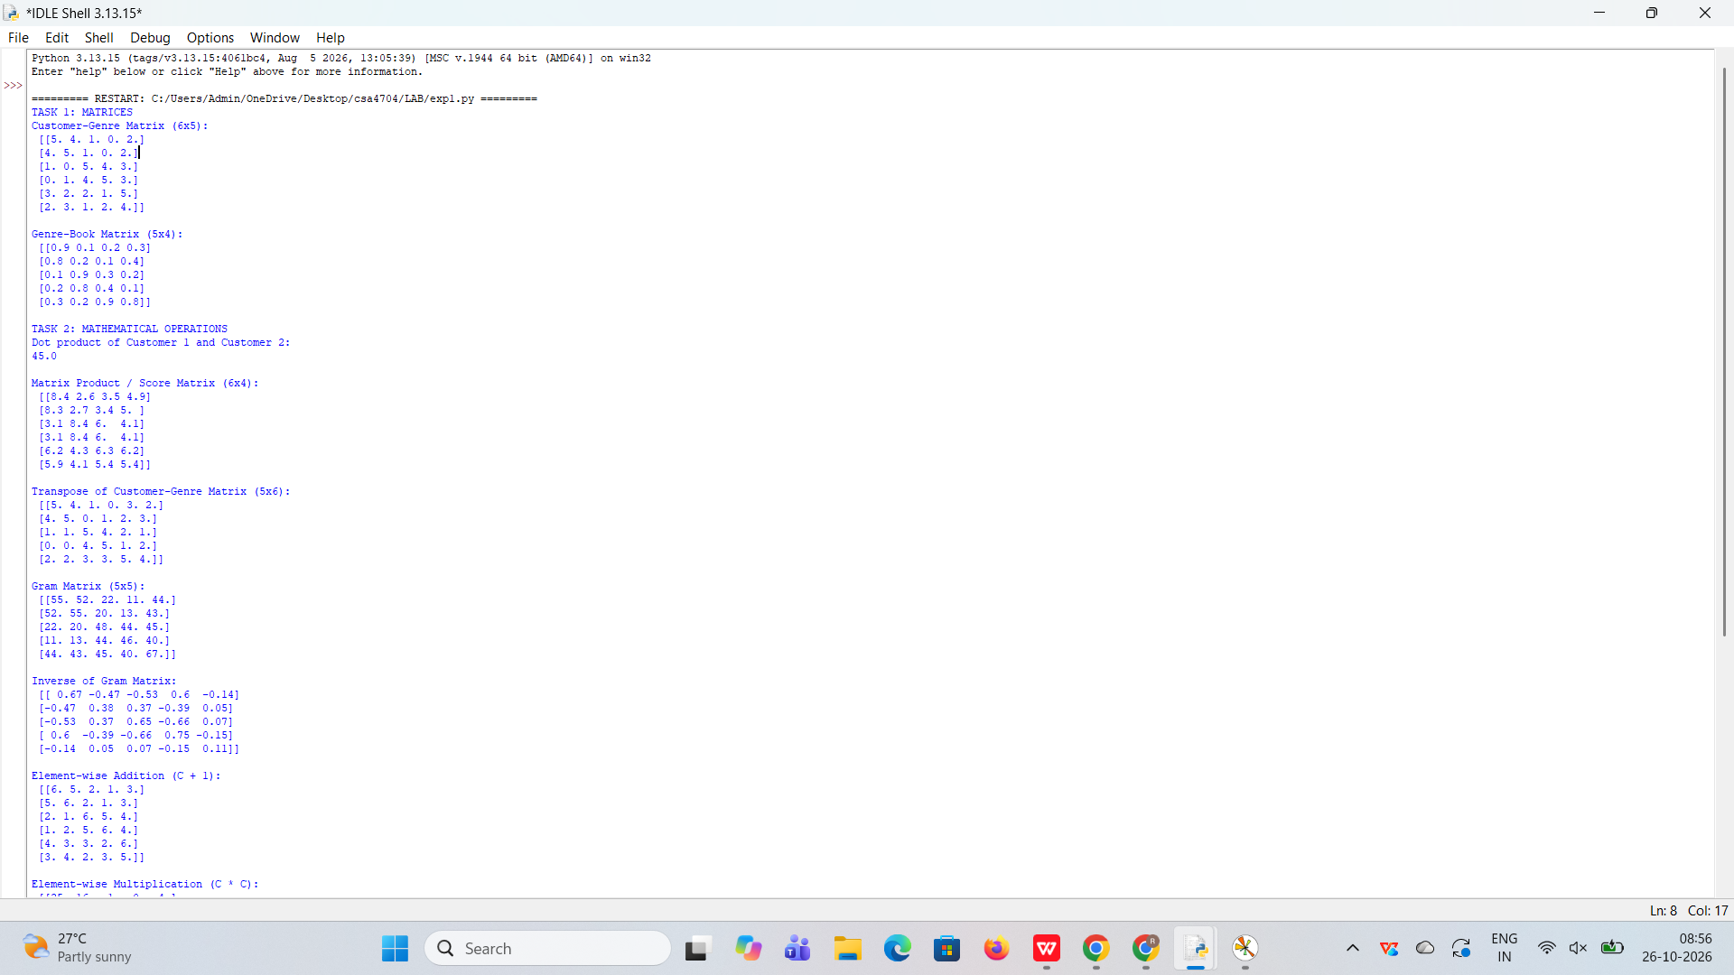
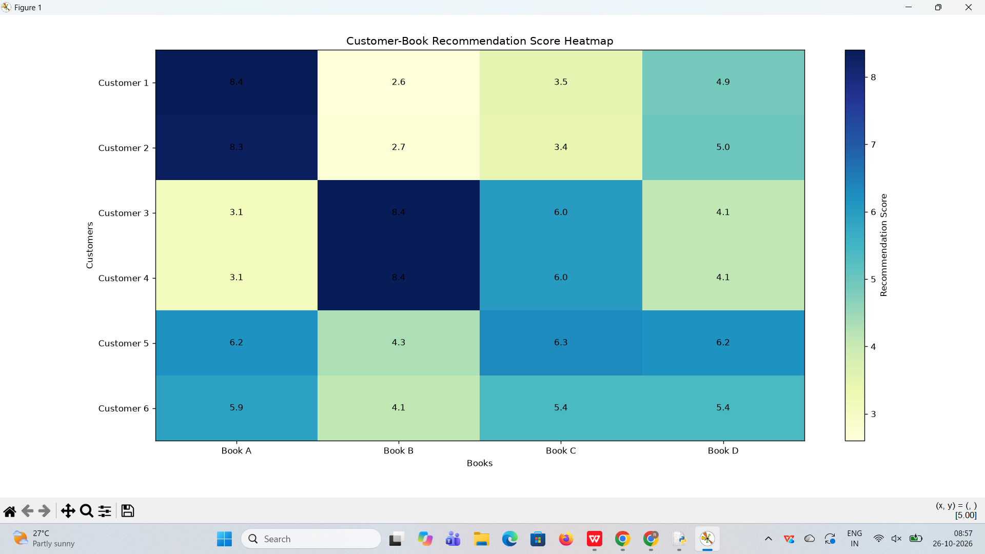

Result
Thus, vector and matrix operations were successfully performed using NumPy. Cosine similarity was used to identify the most similar customers, a dense layer was implemented using \(y=Wx+b\), and the customer–book recommendation scores were visualized using Matplotlib.

